OSSP PRACTICAL EXPERIMENTS 2
M. Yashwant raj (2520030181)

1)
(Cmd executor code program)
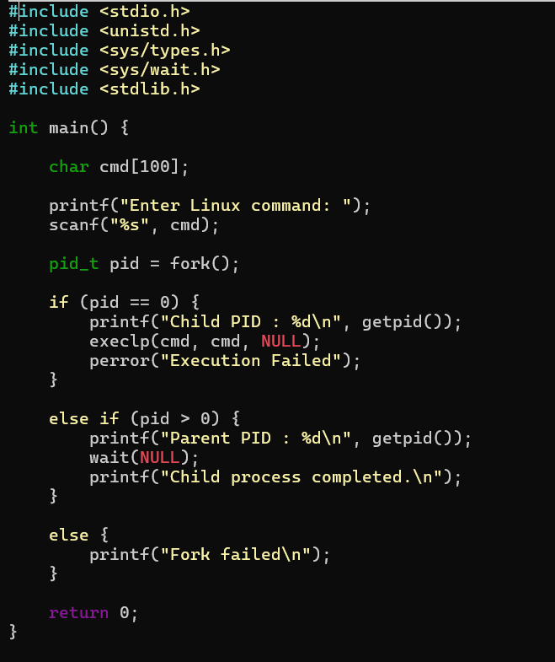
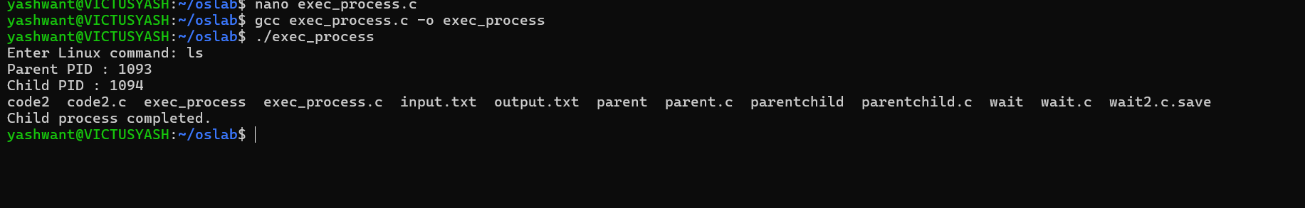

2) Copy content file from “note.txt” to note1.txt”
